**LPG BOOKING SYSTEM**

**Project report**

**Submitted in partial fulfillment of the requirements for the award of degree of**

**INT-213**

**Submitted to :**

**LOVELY PROFESSIONAL UNIVERSITY**

**PHAGWARA,PUNJAB**



**Submitted by:- N. Udaya Krishna Roll num - 67 [11915973]**

1. **Sai Santhosh Roll num -68 [11914653]**

**B.Bala Prasad [11915915]**

**Section : K19TP**

**Student declaration**

We **N.Udaya Krishna , P.Sai Santhosh , B.Bala Prasad** , hereby declare that the work done by me on “**LPG GAS SYSTEM ”** from **August,2020** to **October,2020**, is of original work for the partial fulfillment for the award of the degree, INT **213.**

Brief description of the work done

ABSTRACT:

Our project is based on online booking of LPG gas , it deals the connection interface between the customer and the retailer or seller of the gas , by this the customer can book their gas by anywhere at any time with user friendly interface and they can see their bill and info and address and cost of purchase on their hands.

By this we need not to fill the forms and go to gas store to order gas we can order through online without any effort and extra cost and we can also check bill and it saves time and unnecessary effort .

After once we register and save our info like name address and mobile number by next time it more faster while booking and our needs for gas is at our fingertips.

INTRODUCTION:

this project made by python using tkinter and we the interface is totally user-friendly

the customer , admins can easily understand and make use this interface easily

By this the customer can book the gas from anywhere and anytime on online

And get all benefits as offline and can save time and effort.

BREIF DISSCUSSION ABOUT CODE:

The code starts with importing tkinter and adjusting frames

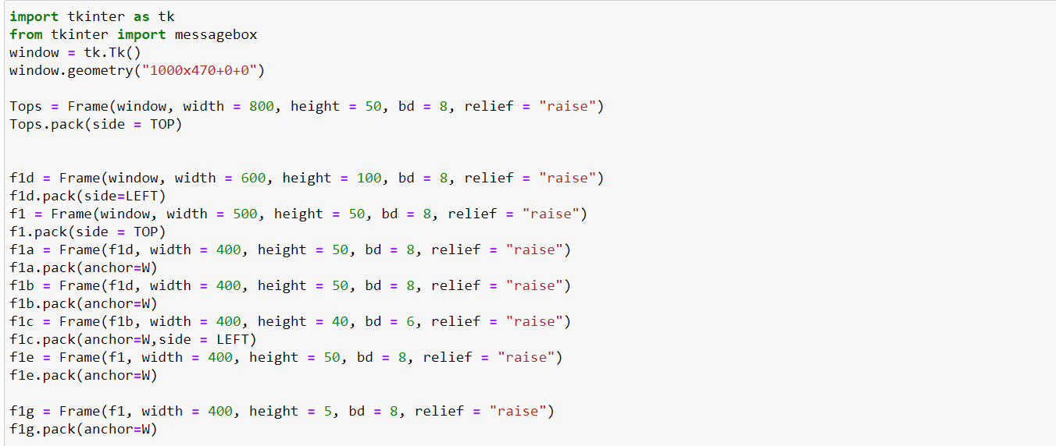

And the title of our project and interface



OUTPUT :-



And next while booking user needs to verify whether their mobile number with OTP

For that we used message box to represent it .

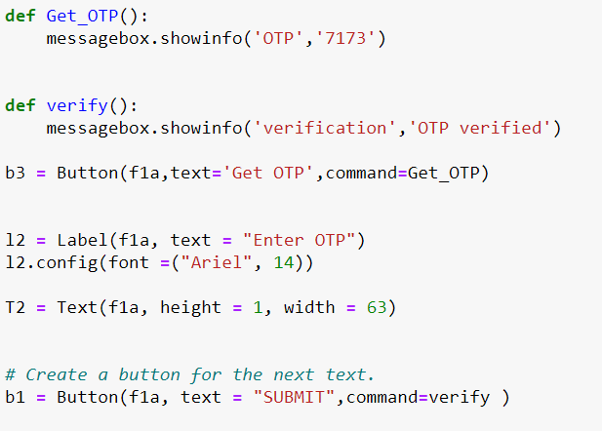

When user enter mobile number and click OTP :-

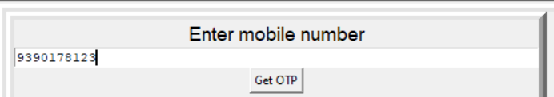

After clicking Get OTP the user gets otp by popup display

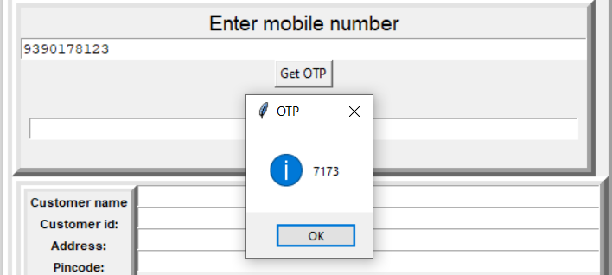

When enter displayed otp and user gets verified :-

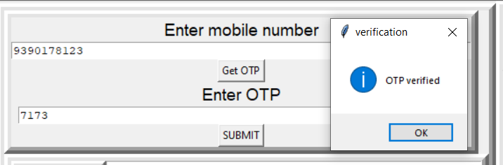

NEXT

Code for entering user details such as name , id , adress , …….

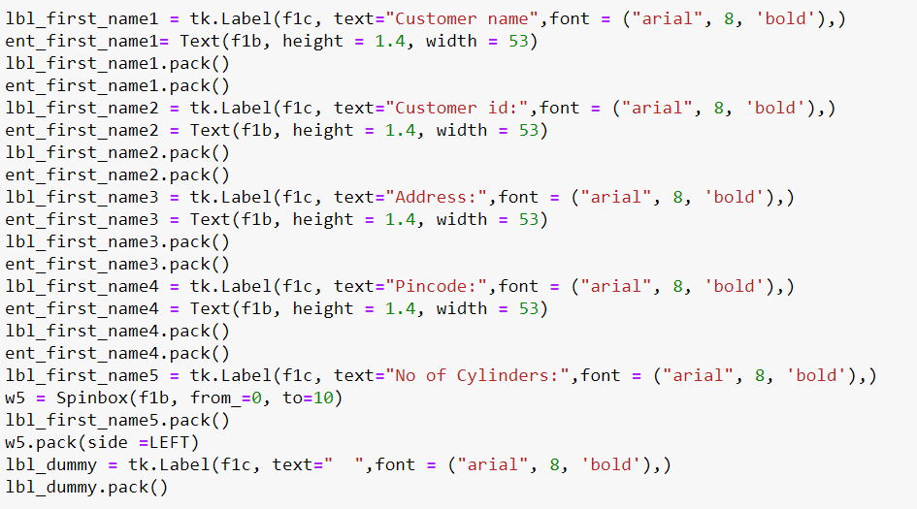

OUTPUT :-

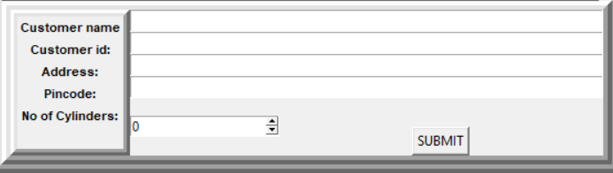

Here Customer enter details

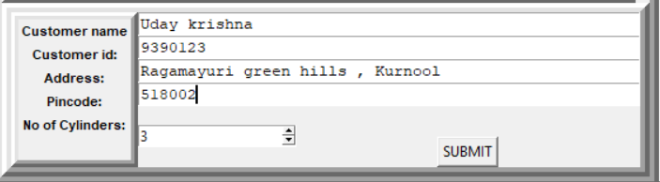

And next the code for collecting these details to get a bill or invoice for the customer

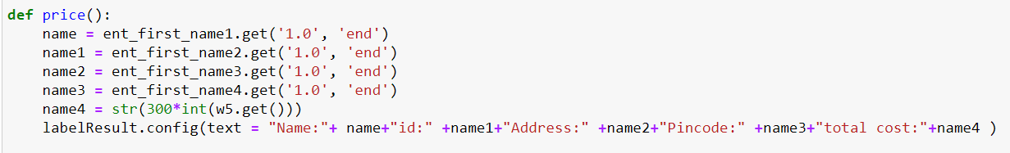

When the customer click to generate bill it displays by caluclating total cost of gas book by customer

The bill appears as :

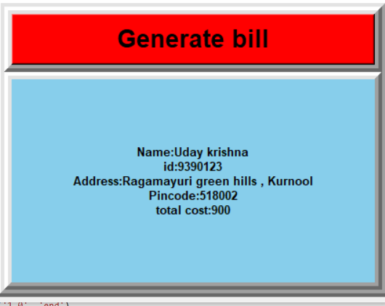

The Final output is :-

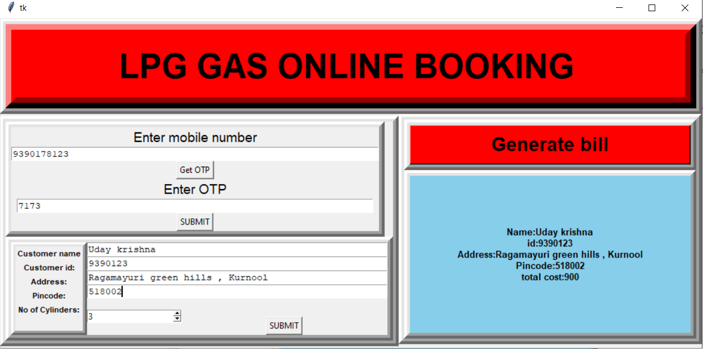

The widgets used in the code are :-

1. Frame:

The Frame widget is very important for the process of grouping and organizing other widgets in a somehow friendly way. It works like a container, which is responsible for arranging the position of other widgets. It uses rectangular areas in the screen to organize the layout and to provide padding of these widgets. A frame can also be used as a foundation class to implement complex widgets.

1. Spin box :

It is allows user to select from given set of values

1. Buttons:

The Button widget is used to add buttons in a Python application. These buttons can display text or images that convey the purpose of the buttons. You can attach a function or a method to a button which is called automatically when you click the button

1. Label :

A Label widget shows text to the user. You can update the widget programmatic ally to, for example, provide a readout or status bar.

1. Entry :

The Entry widget is used to accept single-line text strings from a user.

CONCLUSION:

By this project we came to know the practical implementation of tkinter tools and widgets.

We also learnt how to make user-friendly interface and outputs.

This interface is user-friendly.

the customer , admins can easily understand and make use this interface easily

By this the customer can book the gas from anywhere and anytime on online.